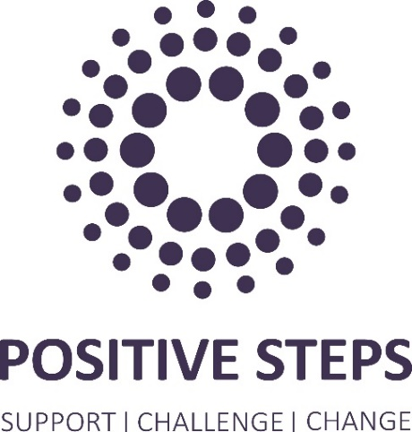
JOB DESCRIPTION: Senior Engagement Worker – Welfare Hub

Job Title: Senior Engagement Worker – Welfare Hub
Location: Hybrid
Team/Directorate: Families and Communities
Responsible To: Operational Manager - Early Intervention and Prevention
Responsible For: N/A

JOB PURPOSE

- Responsible for delivery of a range of interventions to successfully engage adults on probation in the Oldham Welfare Hub to support a reduction in reoffending

PRINCIPAL DUTIES AND RESPONSIBILITIES

- Provide welfare support to adults referred by the Probation Service in line with relevant legislation, National Standards and best practice to safeguard the service

- Develop pathways into the service and relationships with local statutory and community partners to support rehabilitation

- Apply a range of evidence-based tools and techniques for motivating clients to achieve behaviour change

- Coordinate delivery of one-to-one and group coaching for adults on probation with multiple and complex needs

- Undertake accurate, timely recording on digital caseload management system to meet contract requirements and National Standards

- Deputise for EIP Operational Manager where relevant

- Monitor qualitative and quantitative data to provide evidence to inform service delivery and ongoing improvement

- Develop and maintain relationships with partners to improve and enhance the offer and outcomes for adults

- Apply the consistent application of all relevant policies and procedures including safeguarding, health & safety and equality & diversity to ensure a compliant service

- Undertake any other duties to meet service and organisational objectives following consultation with your manager

Key Relationships – Internal & External
- External – Probation service, commissioners, local partners
- Internal – Staff and Volunteers

JOB TITLE Senior Engagement Worker – Welfare Hub

Person Specification

CRITERIA | ESSENTIAL | DESIRABLE
Qualifications and specific training

Experience | - Significant experience of developing relationships and supporting young people, families and/or adults with a range of needs  - Significant experience of planning, monitoring and evaluating your own work  - Demonstrable experience of partnership working at operational levels  - Demonstrable experience of communicating through verbal and written presentations  - Demonstrable success in promoting diversity  - Demonstrable experience of coaching and training staff and/or volunteers
Knowledge | - Understanding of the issues affecting adults known to Probation services and their impact  - Understanding of strength based and trauma informed approaches  - Understanding of safeguarding legislation and guidance, and the boundaries of professional relationships  - Understanding of Health & Safety legal requirements and best practice
Skills | - Developed skills in engaging, coaching and motivating young people and adults where there are a range of needs  - Developed communication, report writing and presentation skills  - Developed skills in creativity and original thinking with the ability to develop practical solutions to problems  - Developed skills in assessment of needs and in developing person centred action plans  - Primary skills in Microsoft Office and database systems  - Primary ability to engage organisations and partnerships  - Basic skills in literacy and numeracy
Personal attributes | - Sound judgement and awareness of organisational and political sensitivities  - Sound professional and tactical judgement and the ability to establish priorities and principles  - Resilient and the ability to work independently as required  - Commitment to Positive Steps vision and values
Additional requirements | - Prepared to work flexibly to meet the needs of customers and the organisation  - Able to travel throughout the region  - Evening and weekend work required  - Enhanced DBS, NPS and BPSS checks required

